MATT LOUI

This document contains the list of prompts I used to prompt Claude, Remotion and CapCut in this YouTube video: https://youtu.be/8oIFBQ9BhVU

By simply copying and pasting the prompt and following the steps in the YT video, you’ll be able to create beautiful motion graphics / animations in seconds.

LUT Generation
Prompt: Please generate a clean, soft pastel .LUT file for my studio YouTube videos. Cinematic, clean.

Counting Numbers SRT
Prompt: Generate a .srt file for me with numbers counting from 0 to 535. Make each subtitle 0.1 seconds long each and have a dollar sign in front of them all.
27 Apr

Motion Backgrounds:
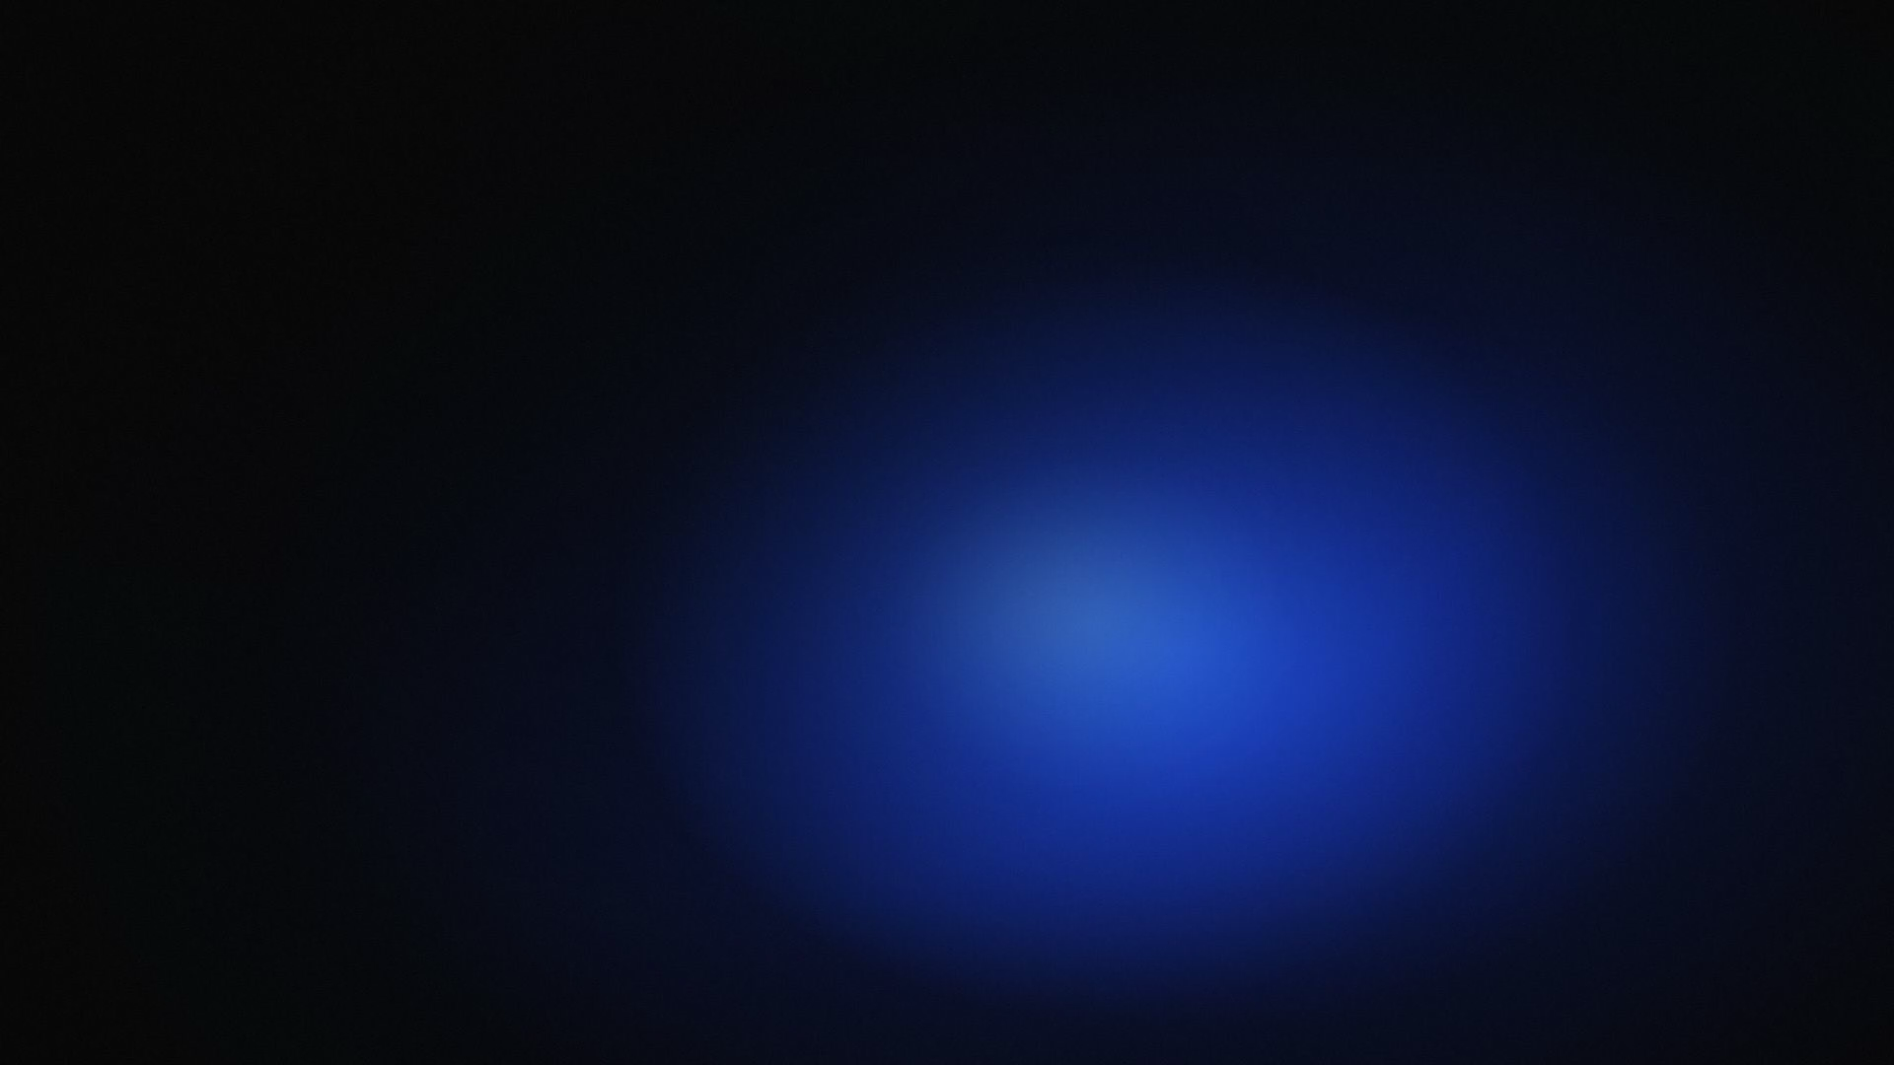
Prompt: Change this reference image using the remotion skill into a premium aesthetic motion background. Change nothing about the colors, the textures, or the way that image looks, simply make this into a premium motion background. Add some grain or texture on top of the image to add a premium feel, and make sure that this is instantly usable. Rotate the image 90 degrees to make the aspect ratio of the project 16 by nine. The overall project should be ten seconds long.

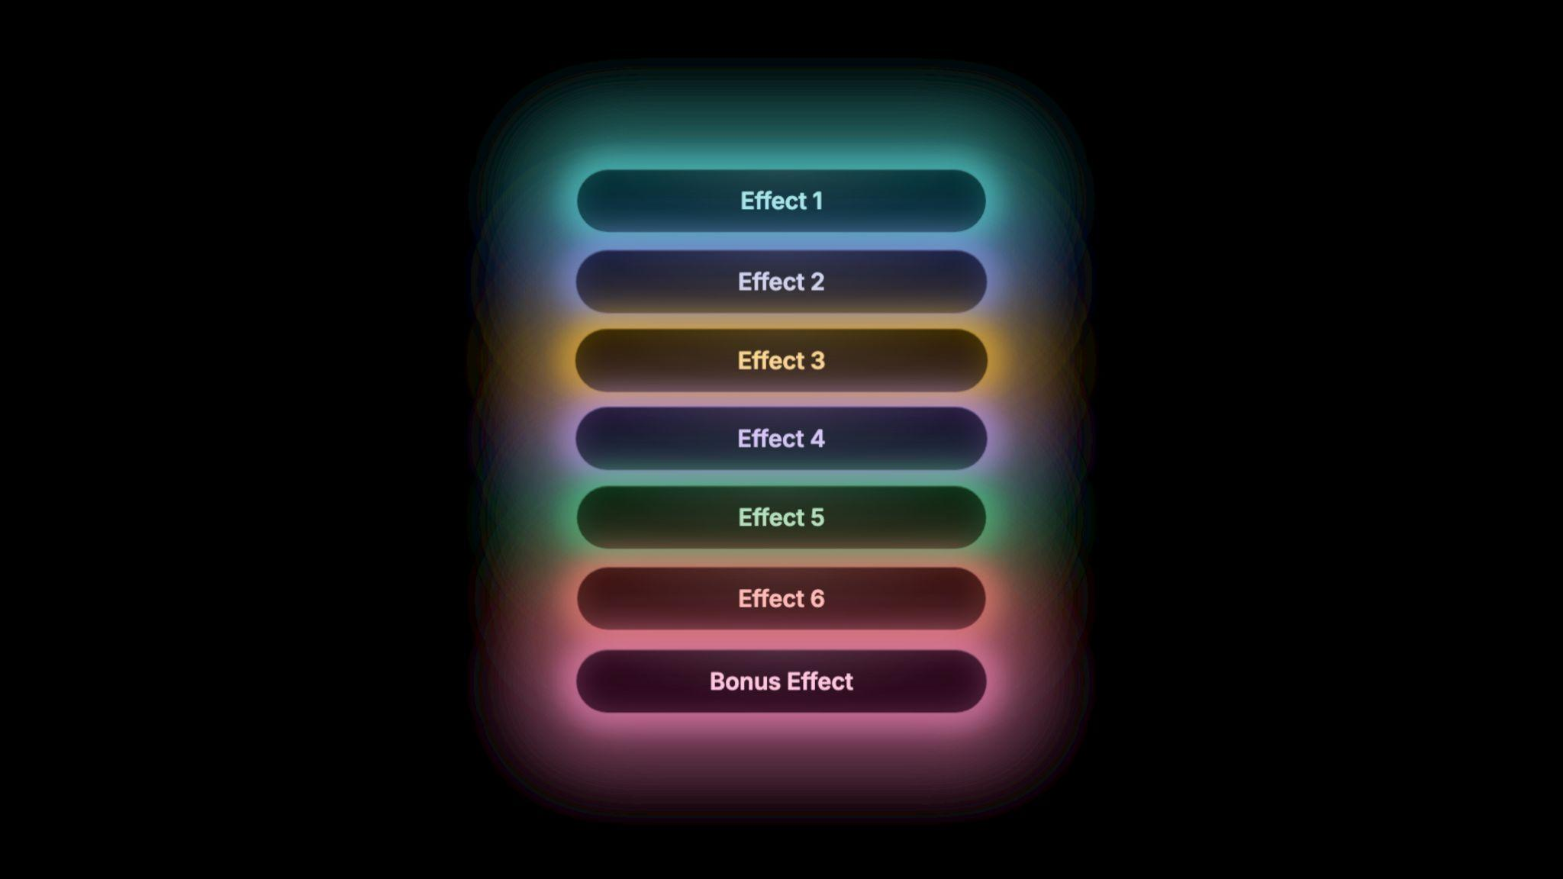
7 Effects List:
Hi Claude, use remotion best practices and the provided image to build a pill type rectangular box. The box should have glows orbiting it (as in the reference, with the same colour scheme). They move on opposite sides of the box and are tracked to the outer perimeter of the box. Smooth movement, circling around). The box should be free of text. Overall a super premium look - infographic / UI type of motion. Please ask me as many questions as you need so we can create magic.

Article Highlight:
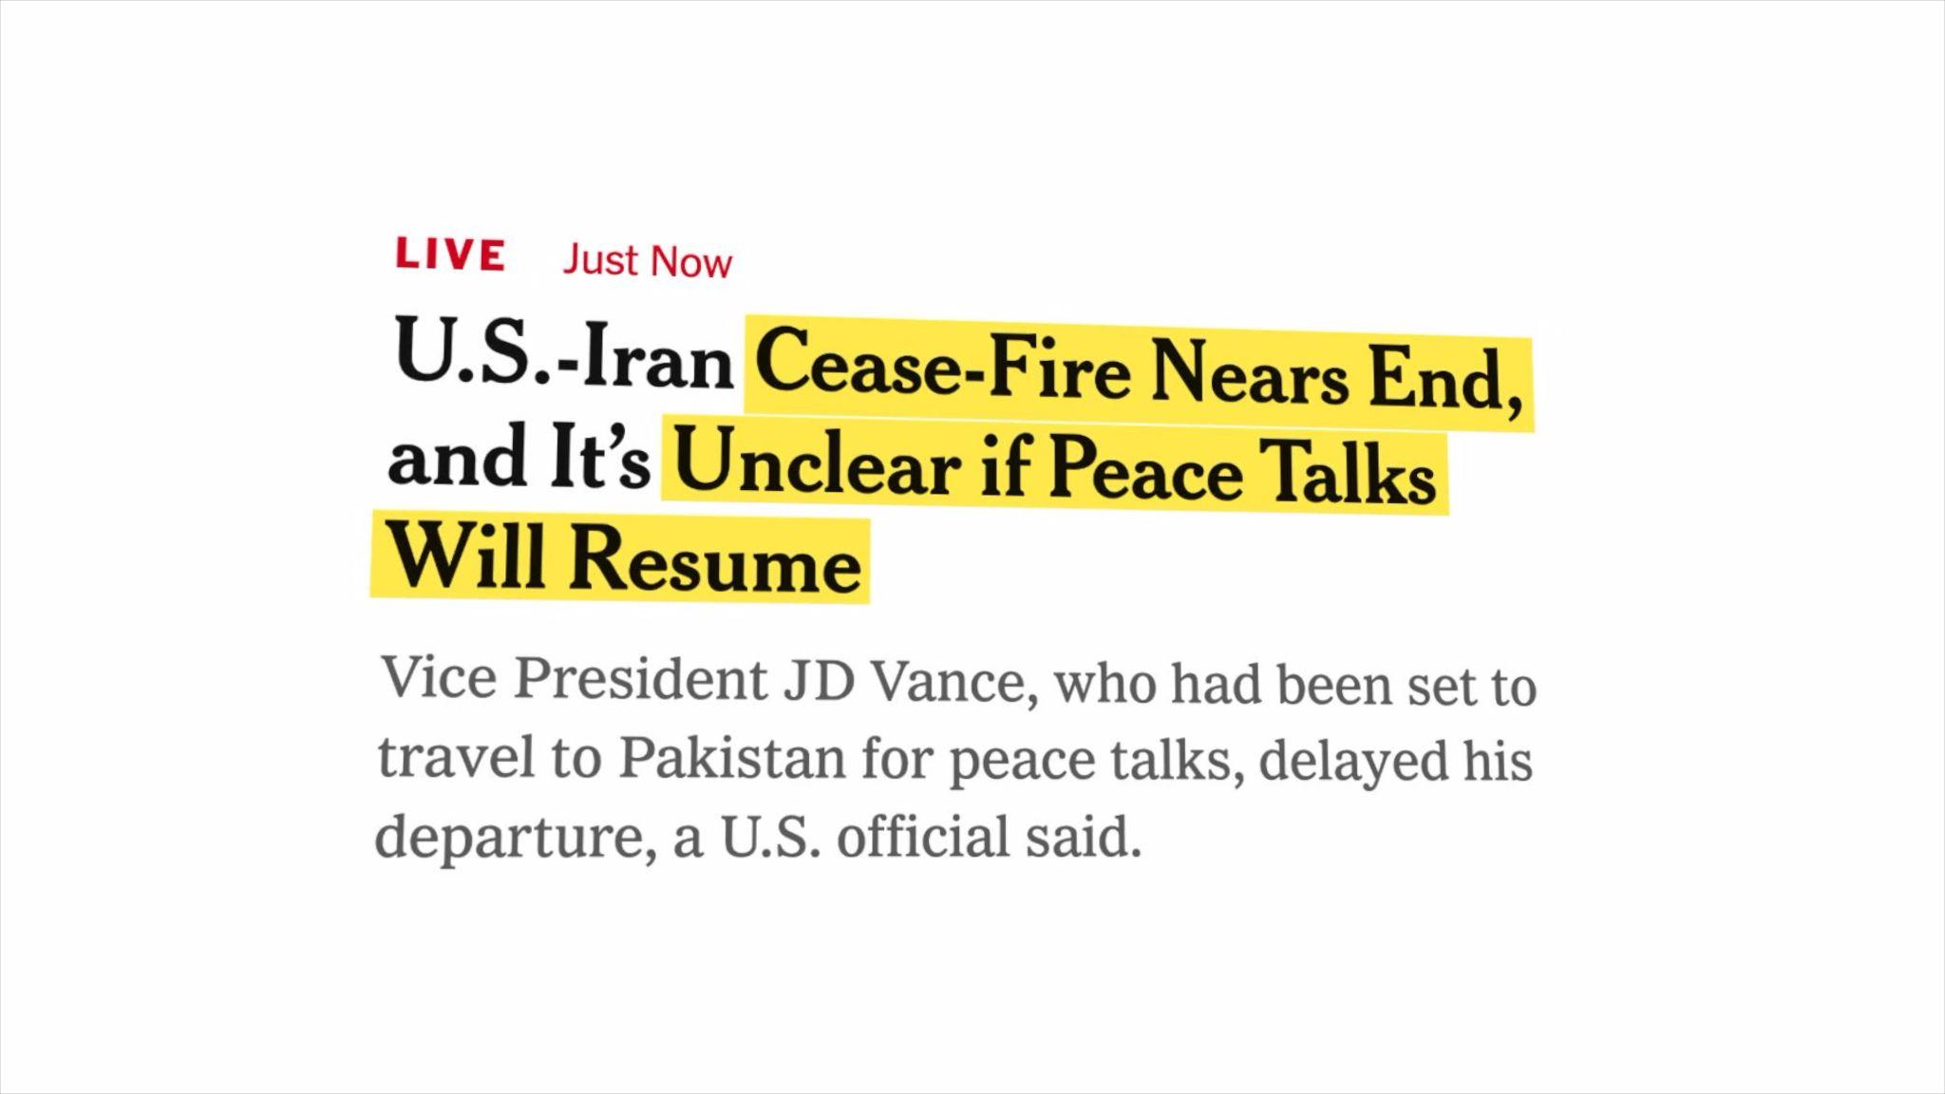
use remotion best practices. import the attached image into the project: ' use tesseract CLI to do OCR and find the positions of the text. in remotion, make a new composition where you load the image and pad the article generously on a white full HD background. while the composition is running for 5 seconds, slowly, very subtly, zoom into it and slightly rotate the article in 3d from left to right. the overall rotation should be around 15deg for each axis. at the beginning, blur the whole composition and unblur it over 1 second. after the blur is done, evolve a highlighter from left to right using rough.js over the words "cease-fire near ends" and "unclear if peace talks will resume". the image has a white background. make sure the the marker appears behind the text. when installing new dependencies, check for existing lockfiles and use the right package manager.

Search Bar:
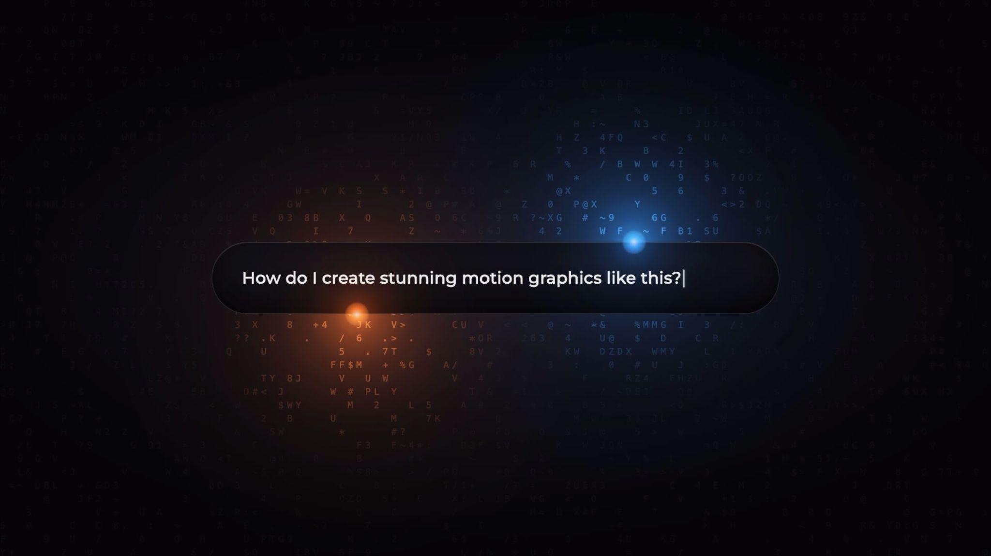
Initial Step (the bar): Hi Claude, use remotion best practices and the provided image to build a pill type rectangular box. The box should have glows orbiting it (as in the reference, with the same colour scheme). They move on opposite sides of the box and are tracked to the outer perimeter of the box. Smooth movement, circling around). The box should be free of text. Overall a super premium look - infographic / UI type of motion. Please ask me as many questions as you need so we can create magic.

Second Step (the writing):
Let's lock in the box design. Now add text - Monserrat font - which types into the pill. It types: How do I create stunning motion graphics like this? Make it genuinely look like someone is typing it - mixed speed of typing, some error letters backspaced and rewritten, etc. Ask any relevant questions.

Map Animation
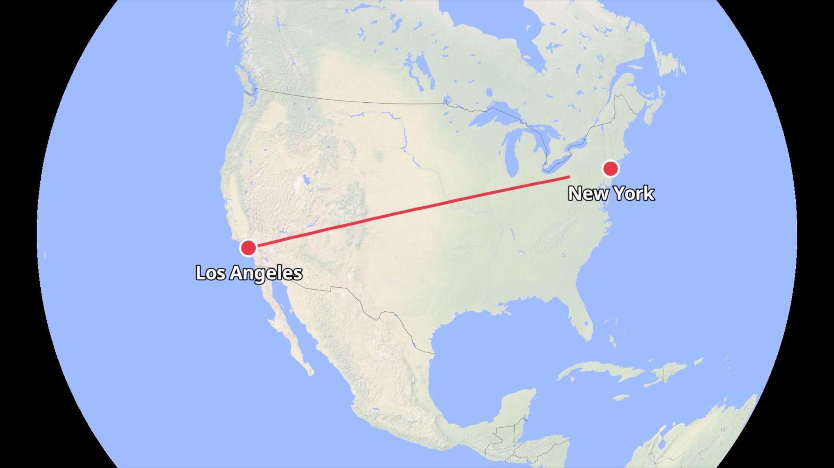
use remotion best practices. make a new composition and add a map and smooth zoom out of LA while staying focused on it. once done, animate a line from LA to NY and make the camera follow it. Smooth, keyframed motion throughout. Use easing curves to ensure acceleration and decelleration. the map should be clean and professional. No sudden movements or motion glitches. Ask me any questions to clarify.

